

**MINI PROJECT REPORT**

On

**“E-Learning Website”**

**Submitted by**

**NAINA JOHRI**

**(**201500422**)**

**ANJALI KUMARI**

**(**201500095**)**

**SHUBHI AGRWAL**

**(201500682)**

Department of Computer Engineering & Applications

**Institute of Engineering & Technology**

**GLA University Mathura- 281406, INDIA**

**2021-2022**

**Department of computer Engineering and Applications GLA University, Mathura**

**17 km. Stone NH#2, Mathura-Delhi Road, P.O. – Chaumuha, Mathura – 281406**

# Declaration

We hereby declare that the work which is being presented in the Mini Project “**E-LEARNING WEBSITE”,** in partial fulfillment of the requirements for Mini Project viva voice, is an authentic record of our own work carried by the team members under the supervision of our mentor **Md. Farmanul Haque.**

### Group Members:

ANJALI KUMARI(201500095)

SHUBHI AGARWAL(201500682)

NAINA JOHRI(201500422)

Course: B.Tech (Computer Science and Engineering)

Year: 3rd

Supervised By:

Md. Farmanul Haque, Senior Trainer,

**Department of computer Engineering and Applications GLA University, Mathura**

**17 km. Stone NH#2, Mathura-Delhi Road, P.O. – Chaumuha, Mathura – 281406**

# Certificate

This is to certify that the project entitled “Job Board Website”, carried out in Mini Project – I, is a bonafide work by Shubhi Agarwal, Naina Johri, Anjali kumari and is submitted in partial fulfillment of the requirements for the award of the degree Bachelor of Technology (Computer Science & Engineering).

_

Supervisor

Md.Farmanul Haque

Senior Trainer

Depart of CEA, GLA University

# About the Project

Our Mini project “E-Learning Website” is an online website. Here user can learn various Computer Science Engineering subjects and we have also provided some courses on CN and OS, two courses on DSA and Web Dev. are coming soon. It consists 6 days bootcamp on React with free certification for everyone, here we have provided the links of some suggested books of some subjects.

# Motivation

E-learing is one of the most great thing in the filed of education because of this we can learn from anywhere but the only thing that we need is internet speed. It save our travelling time .Here in our website we are providing free certificates in our React bootcamp so that students get motivated.

# Requirements

### a) Software Requirements:

* + Technology Implemented: Full Stack Web Development
  + Languages/Technologies Used: HTML, CSS, JAVASCRIPT
  + IDE Used: Visual Studio Code
  + Web Browser: Google Chrome
  + GitHub: GitHub is a code hosting platform for version control and collaboration. It lets you and others work together on projects from anywhere. GitHub Repository: A GitHub repository can be used to store a development project. It can contain folders and any type of files (HTML, CSS, JavaScript, Documents, Data, Images). A GitHub repository should also include a license file and a README file about the project. A GitHub repository can also be used to store ideas, or any resources that you want to share.
  + Visual Studio Code: Visual Studio Code is a free source- code editor made by Microsoft for Windows, Linux and macOS. [7] Features include support for debugging, syntax highlighting, intelligent code completion, snippets, code refactoring, and embedded Git. Users can change the theme, keyboard shortcuts, preferences, and install extensions that add additional functionality. Microsoft has released Visual Studio Code's source code on the VS Code repository of GitHub.com, under the permissive MIT License, while the compiled binaries are freeware.

**b) Hardware Requirements:**

* + Processor Required: Intel i5
  + Operating System: Windows 10
  + RAM: 8GB
  + Hardware Devices: Computer System
  + Hard Disk

# Acknowledgement

We thank the almighty for giving us the courage and perseverance in completing the project. This project itself is an acknowledgement for all those people who have given us their heartfelt co-operation in making this project a grand success. We extend our sincere thanks to Mrs.Farmanul Haque, Technical Trainer at “GLA University, Mathura” for providing his valuable guidance at every stage of this project work. We are profoundly grateful towards the unmatched services rendered by him. And last but not least, we would like to express our deep sense of gratitude and earnest thanks giving to our dear parents for their moral support and heartfelt cooperation in doing the main project.

# Abstract

The main aim of the project is to develop and deploy an e-learning platform that can help students those who wanted to make career in computer science field. This technology helps you to provide the best notes on your subject basis and give extra knowledge along with your course.

It provides the convenient solution to traditional notes making system. We follow a modular approach to learning through this website. This e-learning will automate

the existing manual system with the help of ready -made notes, and it will fulfill all the requirements so that students can receive a valuable education. And they can

utilize their time up to the maximum. It is a need for time to switch to e-learning.

This e-learning (Tech Hero) website will give the advantage of 24x7 and 365 days a year-round access as compared to Instructor-Led Training, which is one time class that must be scheduled. It is cost effective as the course content is once

prepared and can be easily used and modified as per the demand. This type of

education is interactive, interesting, and entertaining way of learning and might possible that it will soon replace the paper books in the form of touch screen tablets.

**Contents**

1. **Introduction:**

Introduction to HTML and CSS........…......

Pre-requisites…………………………..

### Technologies Used:

Frontend……………………………….

1. **List of Figures** 20-26

### Software Testing 27-

31

### Conclusion 32

### Bibliography 33

**Technology Used**

**HTML**

HTML stands forHyper Text Markup Language. It is used to design web pages

using the markup language. HTML is the combination of Hypertext and Markup language. Hypertext defines the link between the web pages and markup

language defines the text document within the tag that define the structure

of web pages.

HTML is used to create the structure of web pages that are displayed on

the World Wide Web (www). It contains Tags and Attributes that are used

to design the web pages. Also, we can link multiple pages using Hyperlinks.

The basic structure of an HTML page is laid out below. It contains the

essential building-block elements (i.e., doctype declaration, HTML, head, title,

and body elements) upon which all web pages are created.

The basic structure of an HTML page is laid out below. It contains the

essential building-block elements (i.e., doctype declaration, HTML, head, title, and body elements) upon which all web pages are created.

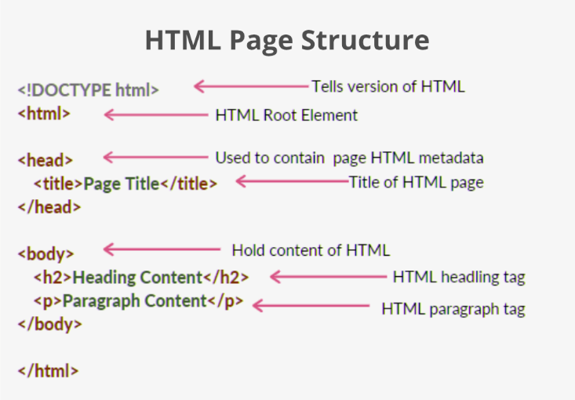

**CSS5**

CSS is the language we use to style an HTML document. CSS describes

how HTML elements should be displayed. CSS stands for Cascading style sheets.

It describes how HTML elements are to be displayed on screen ,paper, or the other media.

CSS saves a lot of work It can control the layout of the multiple web pages

all at once. External stylesheet are stored in CSS files.CSS file extension name is “.css” .

CSS is used along with HTML and JavaScript in most website to create

user interface for web application and user interfaces for many mobile application.

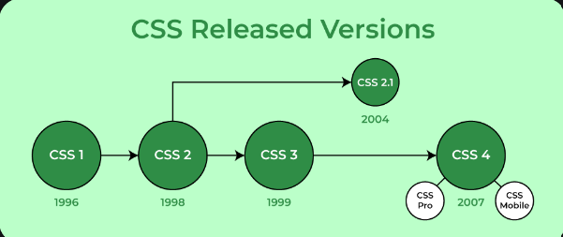

**JavaScript**

JavaScript is a [high-level](https://en.wikipedia.org/wiki/High-level_programming_language), often [just-in-time compiled](https://en.wikipedia.org/wiki/Just-in-time_compilation) language that conforms to the [ECMAScript](https://en.wikipedia.org/wiki/ECMAScript) standard. It has [dynamic typing](https://en.wikipedia.org/wiki/Dynamic_typing), [prototype-based](https://en.wikipedia.org/wiki/Prototype-based_programming) [object-orientation](https://en.wikipedia.org/wiki/Object-oriented_programming), and [first-class functions](https://en.wikipedia.org/wiki/First-class_function). It is [multi-paradigm](https://en.wikipedia.org/wiki/Programming_paradigm), supporting [event-driven](https://en.wikipedia.org/wiki/Event-driven_programming), [functional](https://en.wikipedia.org/wiki/Functional_programming), and [imperative](https://en.wikipedia.org/wiki/Imperative_programming) [programming styles](https://en.wikipedia.org/wiki/Programming_paradigm). It has [application programming interfaces](https://en.wikipedia.org/wiki/Application_programming_interface) (APIs) for working with text, dates, [regular expressions](https://en.wikipedia.org/wiki/Regular_expression), standard [data structures](https://en.wikipedia.org/wiki/Data_structure), and the [Document Object Model](https://en.wikipedia.org/wiki/Document_Object_Model) (DOM).

The ECMAScript standard does not include any [input/output](https://en.wikipedia.org/wiki/Input/output) (I/O),

such as [networking](https://en.wikipedia.org/wiki/Computer_network), [storage](https://en.wikipedia.org/wiki/Data_storage), or [graphics](https://en.wikipedia.org/wiki/Computer_graphics) facilities. In practice, the

web browser or other [runtime system](https://en.wikipedia.org/wiki/Runtime_system) provides JavaScript APIs for I/O.

[JavaScript engines](https://en.wikipedia.org/wiki/JavaScript_engines) were originally used only in web browsers,

but are now core components of some [servers](https://en.wikipedia.org/wiki/Server_(computing)) and a variety of [applications](https://en.wikipedia.org/wiki/Application_software).

The most popular runtime system for this usage is [Node.js](https://en.wikipedia.org/wiki/Node.js).

Although [Java](https://en.wikipedia.org/wiki/Java_(programming_language)) and JavaScript are similar in name, [syntax](https://en.wikipedia.org/wiki/Syntax_(programming_languages)), and respective

[standard libraries](https://en.wikipedia.org/wiki/Standard_library), the two languages are distinct and differ greatly in design.

**Boot Strap**

Bootstrap is a free and open-source CSS framework directed at

responsive, mobile-first front-end web development. It contains HTML,

CSS and (optionally) JavaScript-based design templates for typography,

forms, buttons, navigation, and other interface components.

Bootstrap is an HTML, CSS and JS Library that focuses on simplifying the development of informative web pages (as opposed to web apps). The

primary purpose of adding it to a web project is to apply Bootstrap's choices

of color, size, font and layout to that project.

Bootstrap also comes with several JavaScript components which do not

require other libraries like jQuery. They provide additional user interface

elements such as dialog boxes, tooltips, progress bars, navigation

drop-downs, and carousels. Each Bootstrap component consists of an

HTML structure, CSS declarations, and in some cases accompanying

JavaScript code.

**Firebase**

Firebase is a set of hosting services for any type of application

(Android, iOS, JavaScript, Node.js, Java, Unity, PHP, C++ ...). It offers

NoSQL and real-time hosting of databases, content, social authentication

(Google, Facebook, Twitter and GitHub), and notifications, or services,

such as a real-time communication server.

Firebase Realtime Database is the backend service which is provided by

Google for handling backend tasks for your Android apps, IOS apps as

well as your websites.

Firebase hosting is not only free service, its an easy way to host as well,

as its default provides the SSL certificate so that your website will be

hosted securely with HTTPS.

Firebase's first product was the Firebase Realtime Database, an API that synchronizes application data across iOS, Android, and Web devices,

and stores it on Firebase's cloud.

**List Of Figures**

**Home Page**

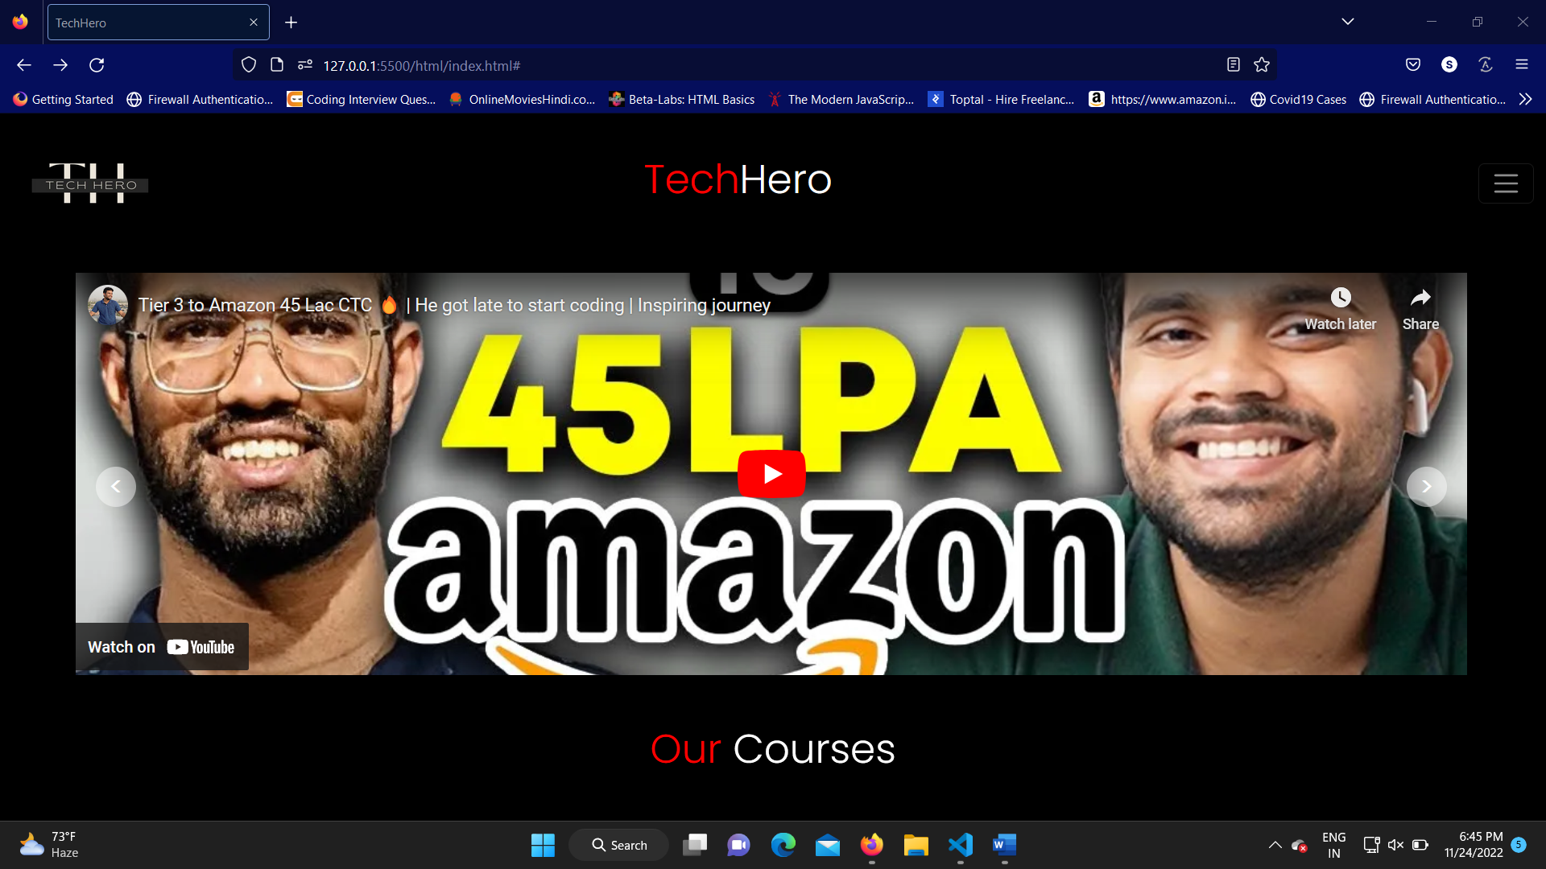

For any website, the home page is the main page which tells the basic idea of the whole website. In this website the home page

have interview videos which will help the users to know about the insides of the interview.

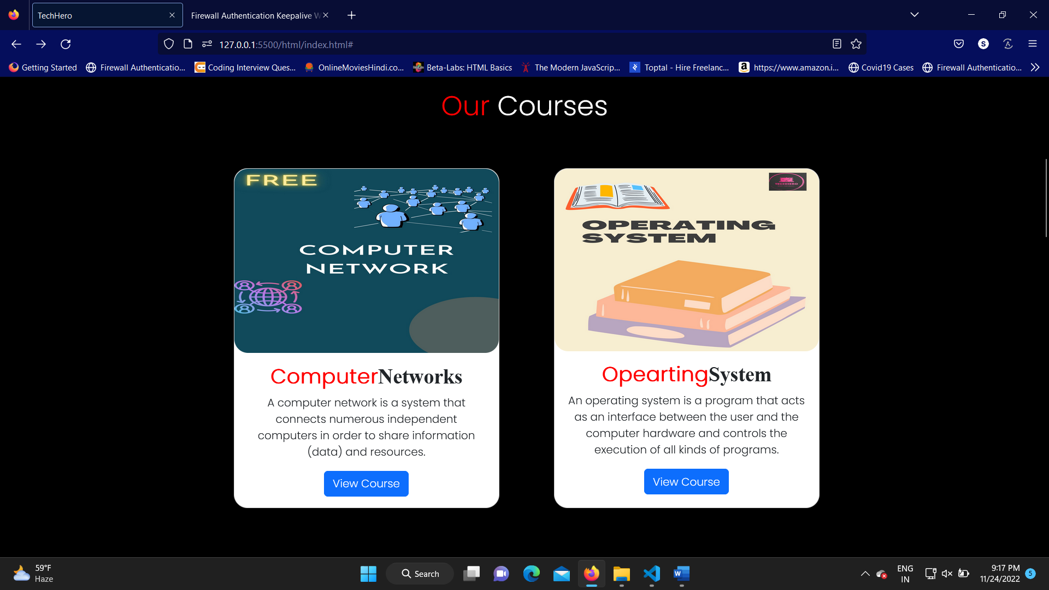The user will be able to access all the free materials of some courses which is being asked in technical rounds as well as in acadmic exams inside our course section .

Some of the courses are coming soon .

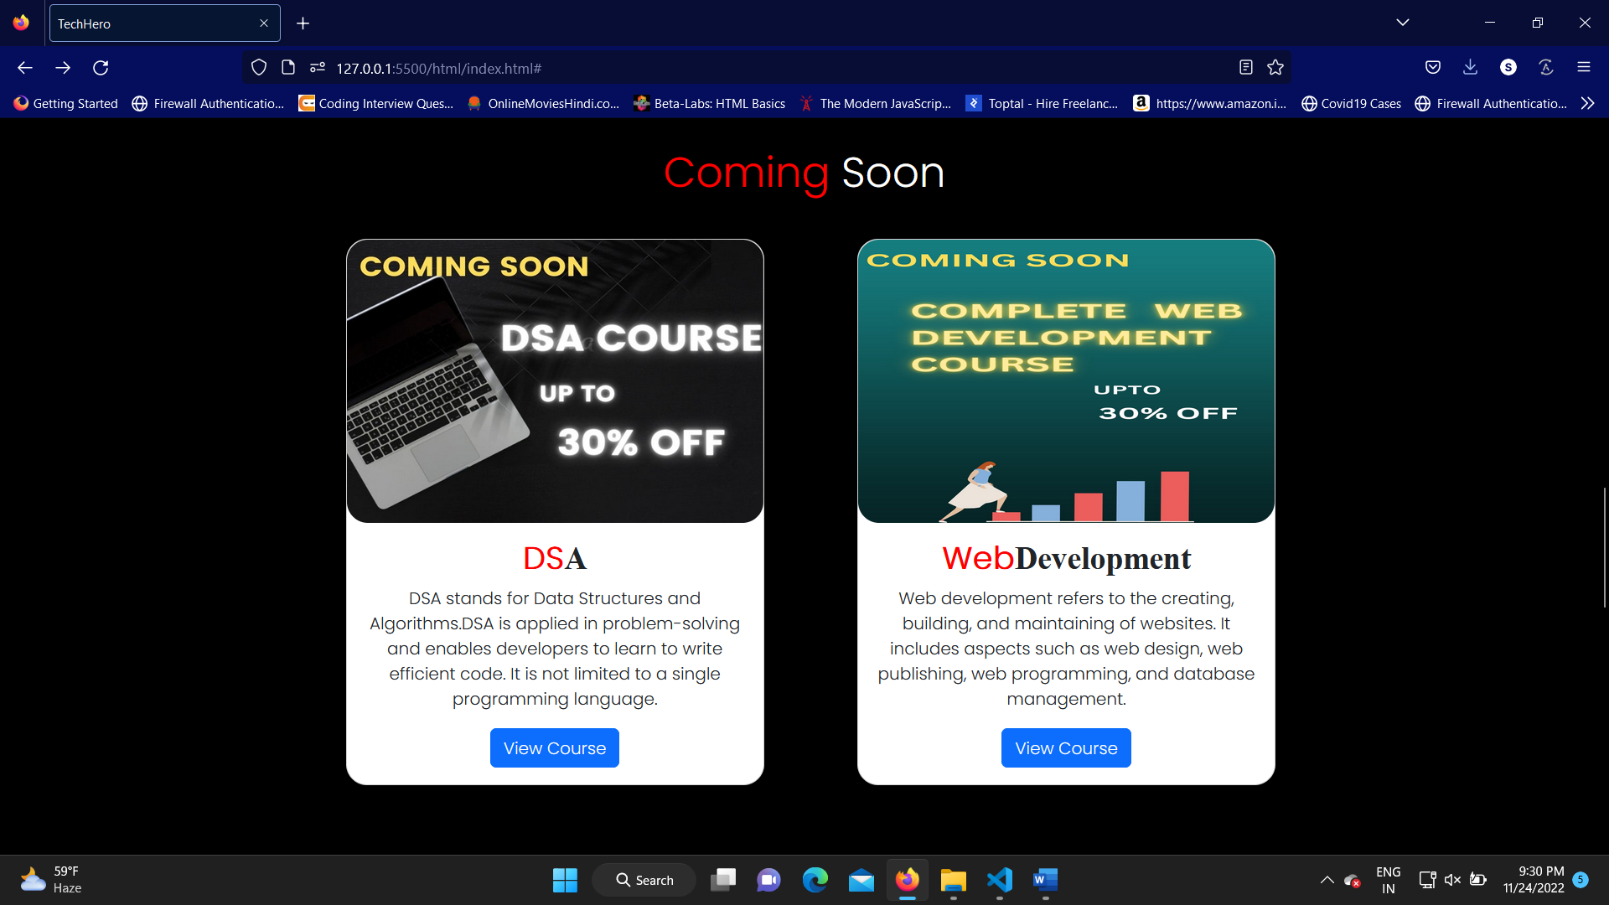

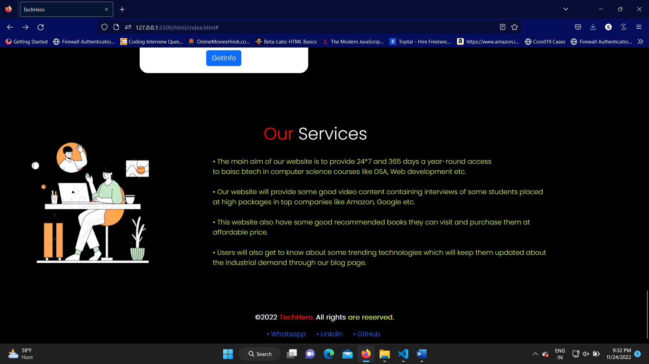

**About Us**

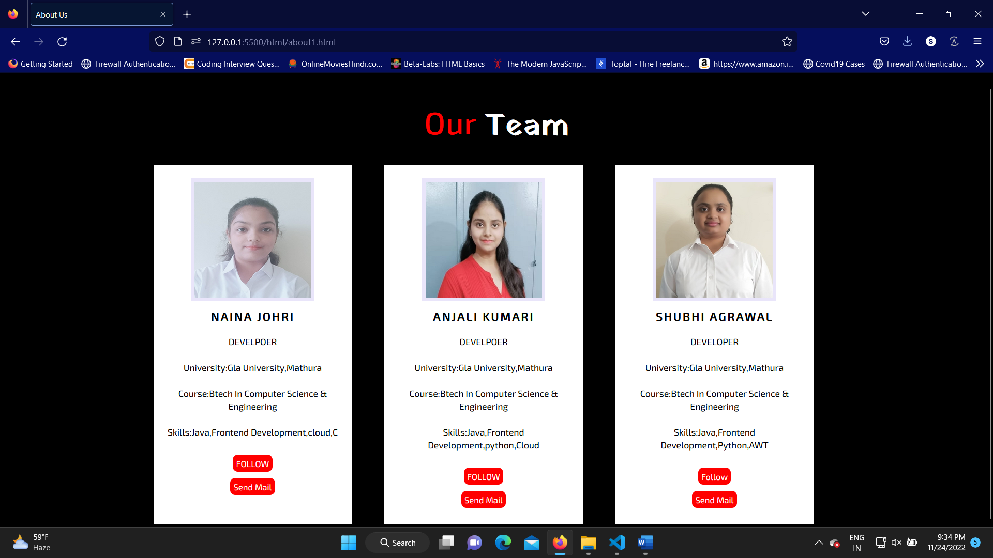

This is the about us page which shows the people behind the website and helps the user to connect with them

This page of the website is an essential source of information for those who want to know more about the business.

**To-Do List**

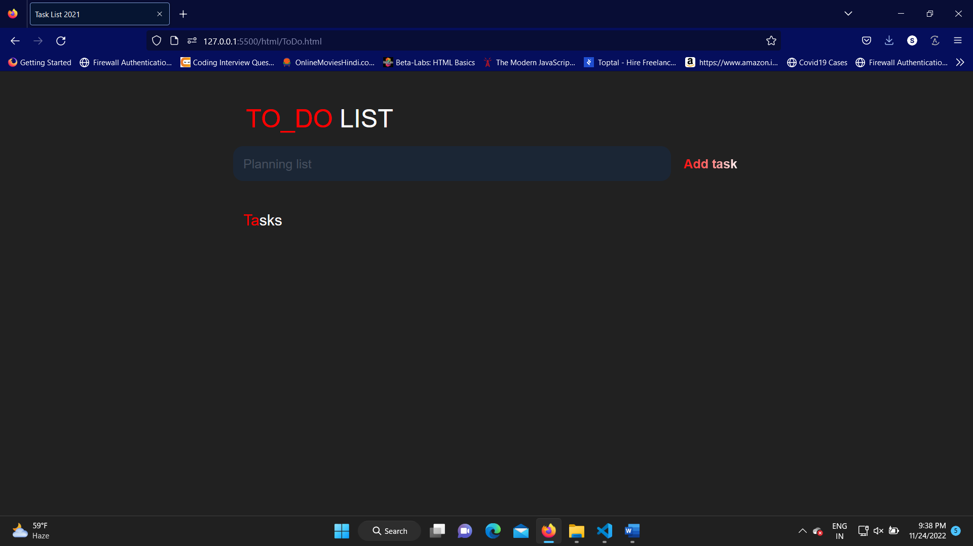

This is the To-Do List which will let the user maintain the list of their daily task . They can save it and when they finish the task they can also delete the task which will help the user to maintain the consistency in their studies.

**Recommended Books**

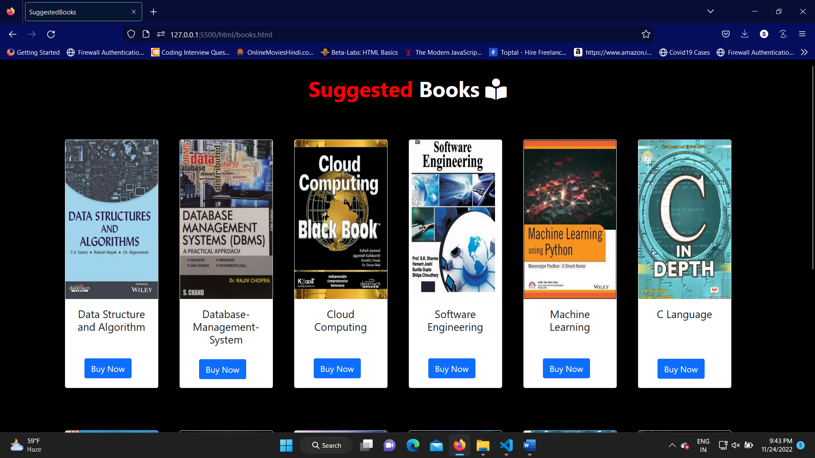

These are some books of various technologies which is highly recommended by various students who have studied from it. The users can buy these books at the affordable price.

**Educational Blogs**

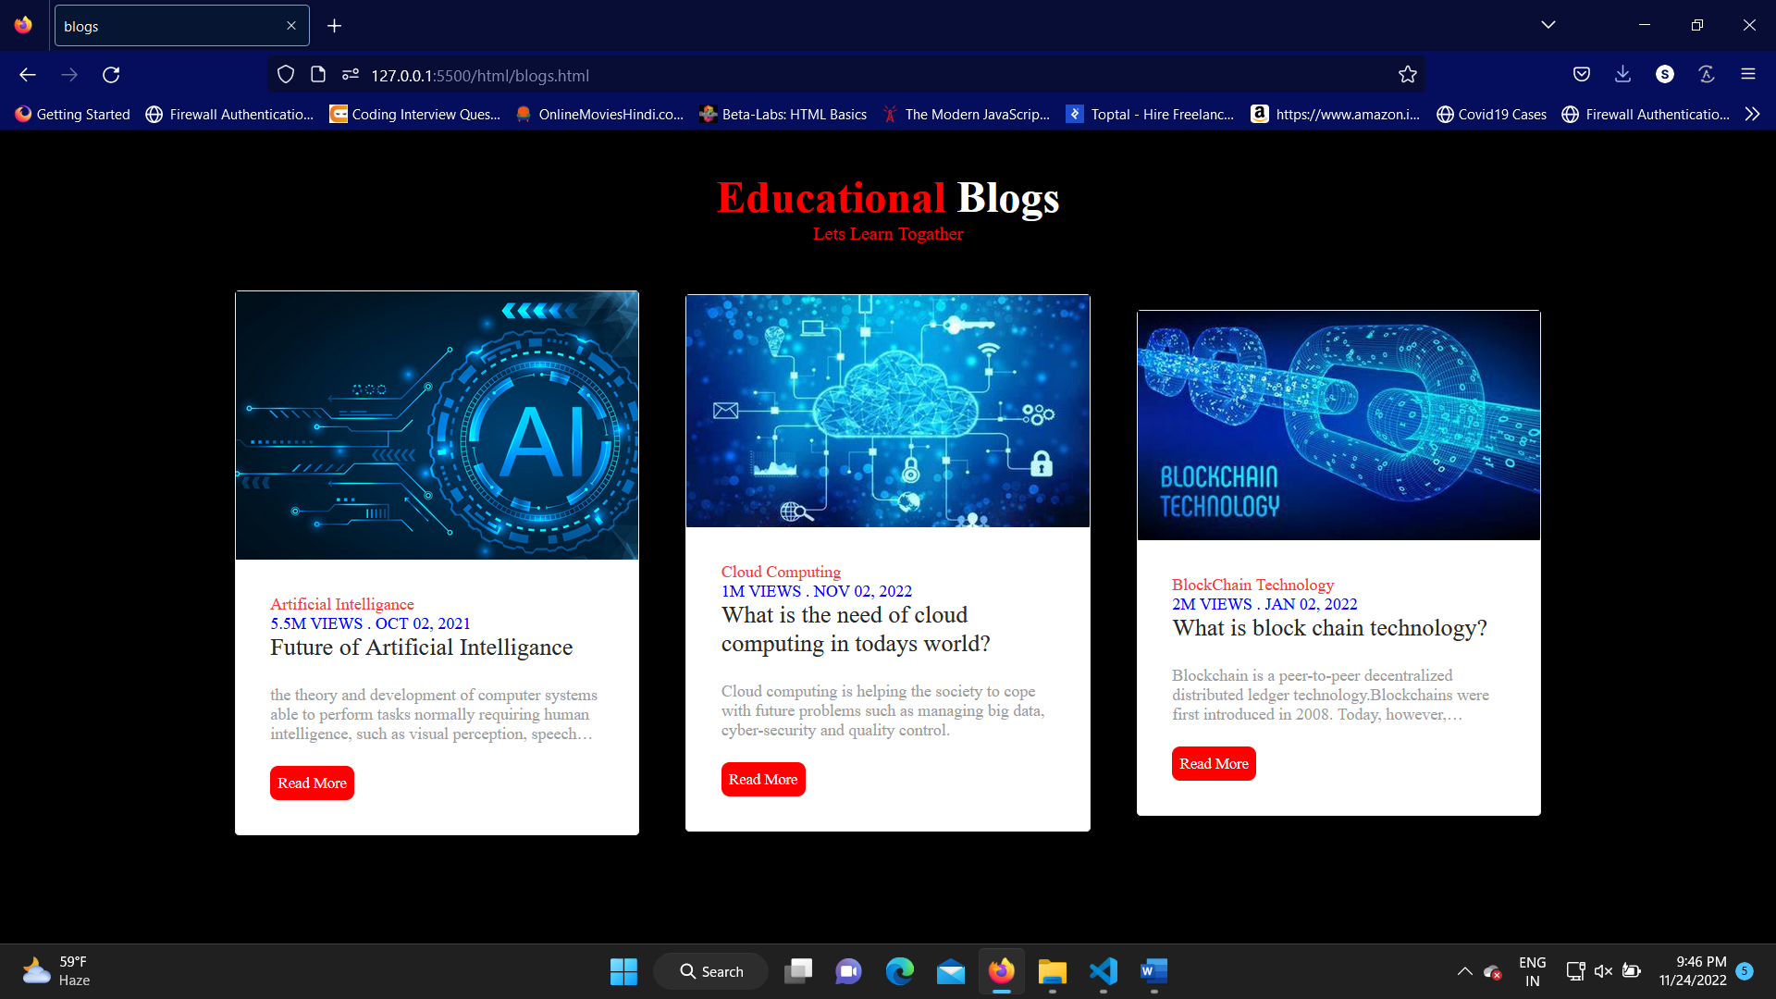

These are some blogs of some latest technologies having high demand in the industry

users will get help as this will keep them updated and they can get more information about these technologies.

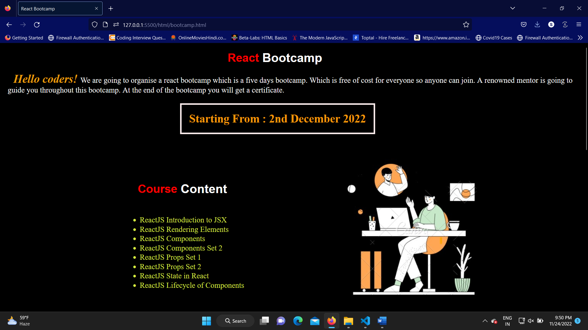

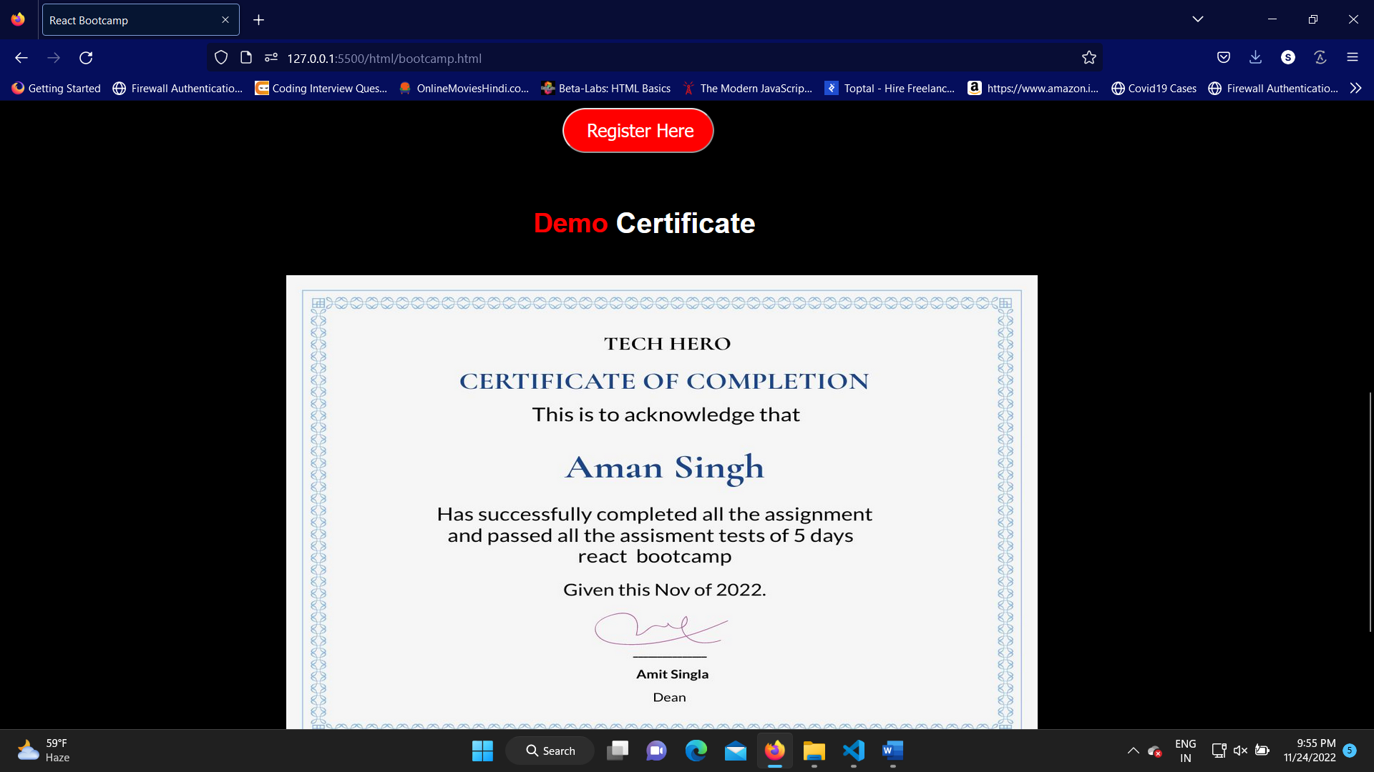

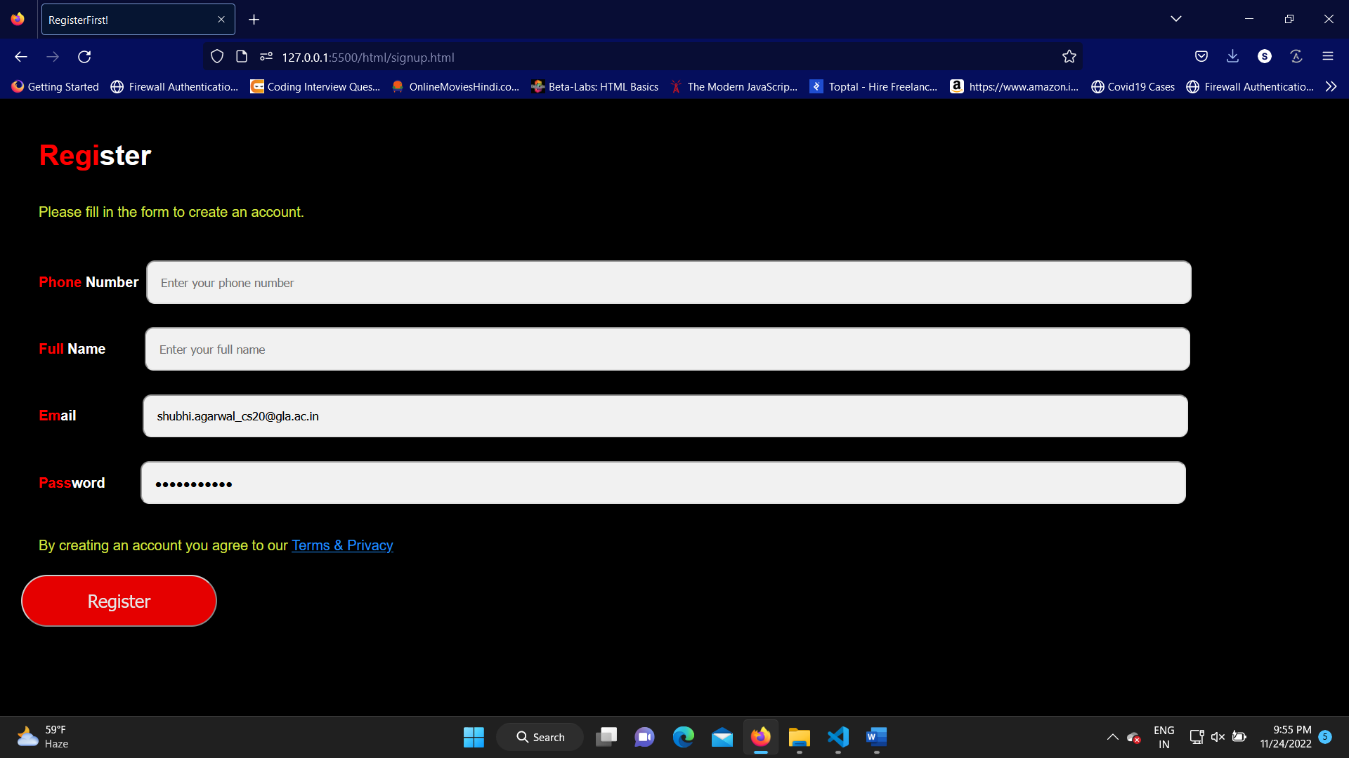

This is the registration page through which user can register themselves in our upcoming bootcamp

In this form the data of the users are saved in the firebase.

**Data Flow Diagram**



This website is based on the data flow diagram mentioned above as user needs to register themselves in order to have access to our upcoming bootcamps. We also have recommended book section through which users can purchase the books at affordable prices.

**Software Testing**

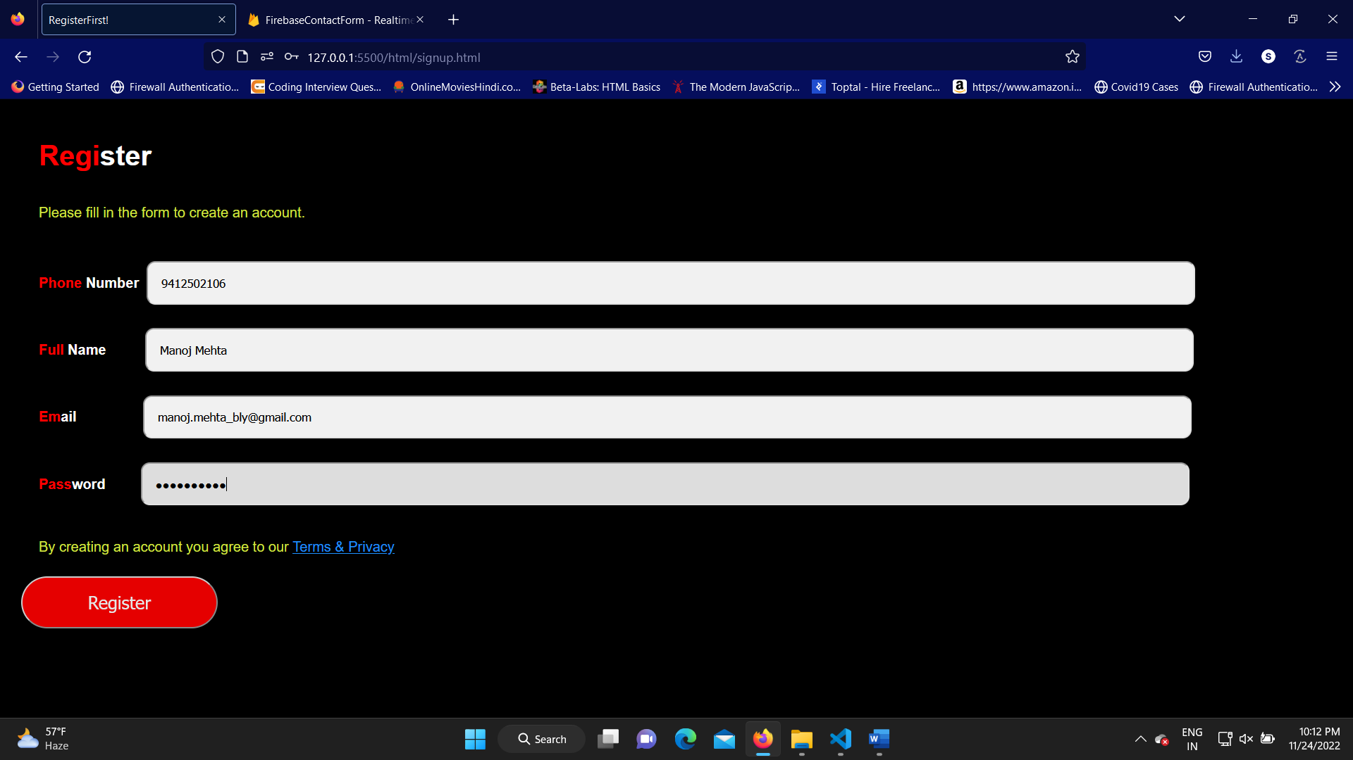

# User will enter its credentials and their data will be saved in firebase.

# 

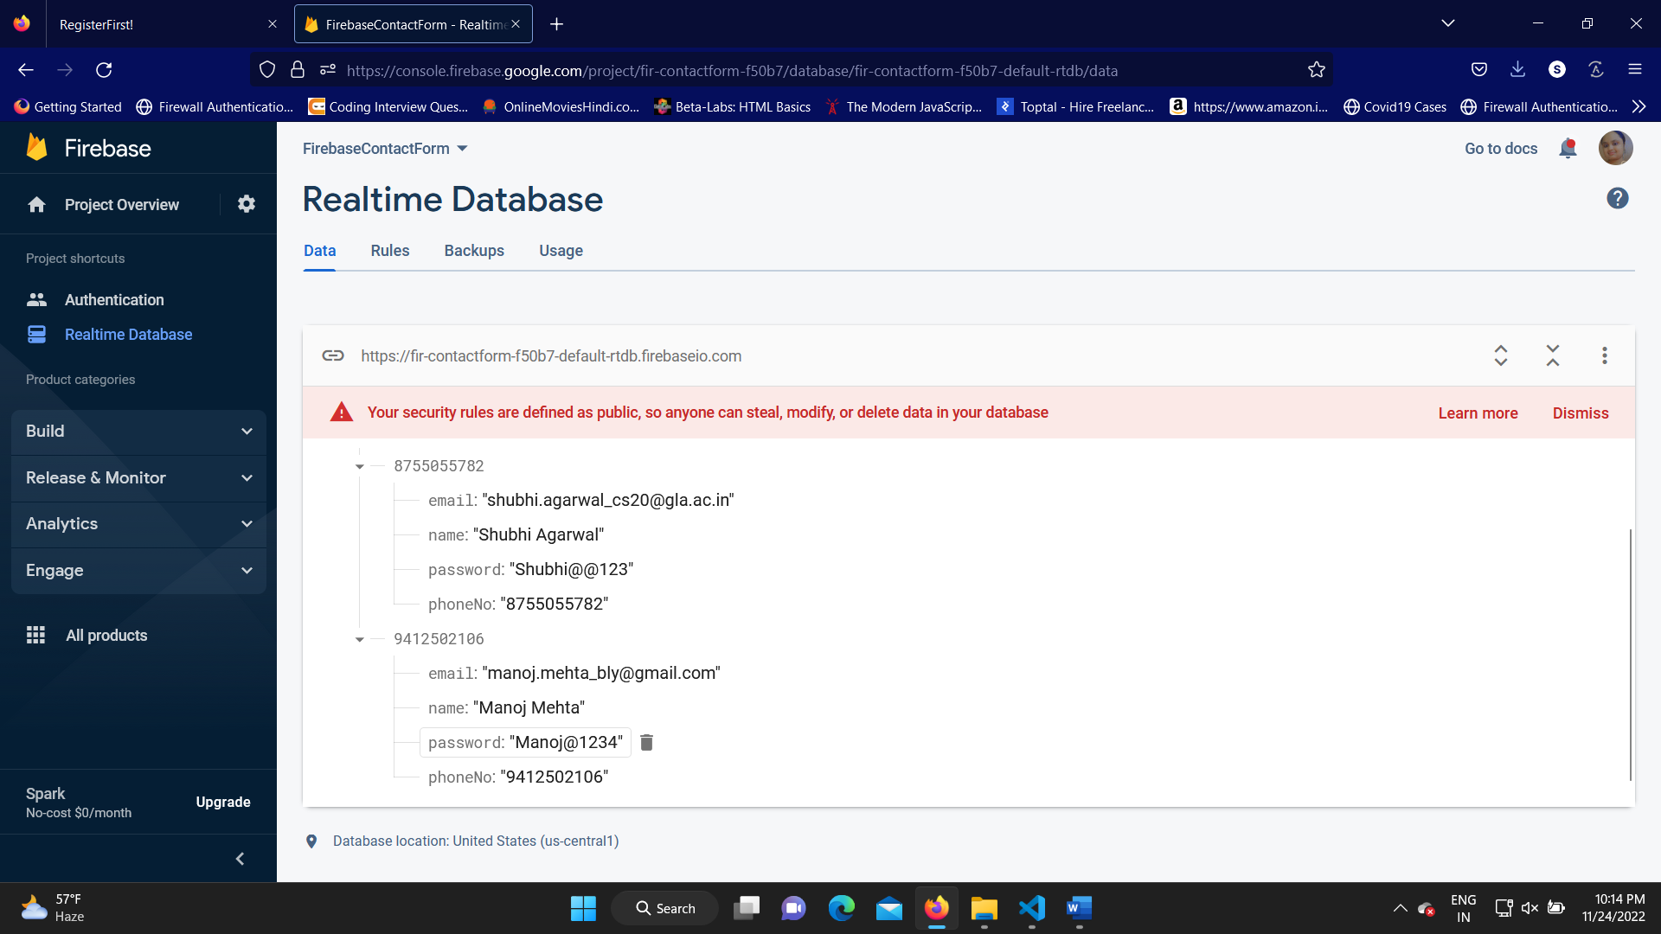

**Conclusion**

With Tech Hero website user will be able to access all the study material

from one place as we have provided enough study material related to various

technology and basic engineering subjects .

Website also contain a to-do list which will help the user to maintain their

Task at one place which will make them consistent towards their studies.

With the recommend book section user can buy books and they can attend

Our free react and other bootcamps launched by TechHero just by registering themselves .

We have a register page through this users can get themselves registered

And their data will be saved in firebase which have been included

as backend to maintain the data of the various users.

**Bibliography**

* **www.javatpoint.com**
* **www.geekforgeeks.com**
* **www.w3schools.com**

**Books:**

• Web design with HTML,CSS,JavaScript and Jquery Set

• Web design with HTML and CSS

**Faculty Guidelines:**

Md Farmanul Haque(Technical Trainer of GLA University)